# A Project Report on

**SMART FASHION RECOMMENDER APPLICATION**

Under the guidance of

# Industry Mentor Prof. Krishna Chaitanya

**Faculty Mentor Dr. R. Mekala AP/IT**

# TEAM ID: PNT2022TMID16242

Submitted by,

ARUN S (927619BIT4004) DHINAKARAN R S (927619BIT4016) KAVIN KUMAR M (927619BIT4048) MOHAN KUMAR S (927619BIT4056)

## DEPARTMENT OF INFORMATION TECHNOLOGY M.KUMARASAMY COLLEGE OF ENGINEERING

**(Autonomous)**

KARUR – 639 113

NOV 2022

# TABLE OF CONTENTS

|  |  |  |
| --- | --- | --- |
| **Chapter No.** | **Title** | **Page No.** |
| 1 | INTRODUCTION |  |
|  | 1.1 PROJECT OVERVIEW |  |
|  | 1.2 PURPOSE |  |
| 2 | LITERATURE SURVEY |  |
|  | 2.1 EXISTING PROBLEM |  |
|  | 2.2 REFERENCES |  |
|  | 2.3 PROBLEM STATEMENT DEFINITION |  |
| 3 | IDEATION & PROPOSED SOLUTION |  |
|  | 3.1 EMPATHY MAP CANVAS |  |
|  | 3.2 IDEATION & BRAINSTORMING |  |
|  | 3.3 PROPOSED SOLUTION |  |
|  | 3.4 PROBLEM SOLUTION FIT |  |
| 4 | REQUIREMENT ANALYSIS |  |
|  | 4.1 FUNCTIONAL REQUIREMENT |  |
|  | 4.2 NON-FUNCTIONAL REQUIREMENTS |  |
| 5 | PROJECT DESIGN |  |
|  | 5.1 SOLUTION & TECHNICAL ARCHITECTURE |  |
|  | 5.2 USER STORIES |  |
| 6 | PROJECT PLANNING & SCHEDULING |  |
|  | 6.1 SPRINT PLANNING & ESTIMATION |  |
|  | 6.2 SPRINT DELIVERY SCHEDULE |  |
|  | 6.3 REPORTS FROM JIRA |  |
| 7 | CODING & SOLUTIONING |  |
|  | 7.1 FEATURE 1 |  |
|  | 7.2 FEATURE 2 |  |
|  | 7.3 DATABASE SCHEMA |  |
| 8 | TESTING |  |
|  | 8.1 TEST CASES |  |
|  | 8.2 USER ACCEPTANCE TESTING |  |
| 9 | RESULTS |  |
|  | 9.1 PERFORMANCE METRICS |  |

|  |  |  |
| --- | --- | --- |
| 10 | ADVANTAGES & DISADVANTAGES |  |
| 11 | CONCLUSION |  |
| 12 | FUTURE SCOPE |  |
| 13 | APPENDIX |  |
|  | 13.1 SOURCE CODE |  |
|  | 13.2 GITHUB & PROJECT DEMO LINK |  |

1. **INTRODUCTION**

# Project Overview

Fashion is a kind of symbol that represents people’s internal perceptions through their outer appearance. It conveys information about their choices, faith, personality, profession, social status, and attitude towards life. Therefore, clothing is believed to be a nonverbal way of communicating and a major part of people’s outer appearance .Recent technological advancements have enabled consumers to track current fashion trends around the globe, which influence their choices. The fashion choices of consumers depend on many factors, such as demographics, geographic location, individual preferences, interpersonal influences, age, gender, season, and culture . Moreover, previous fashion recommendation research shows that fashion preferences vary not only from country to country but also from city to city. The combination of fashion preferences and the above mentioned factors associated with clothing choices could transmit the image features for a better understanding of consumers’ preferences.Therefore, analyzing consumers’ choices and recommendations is valuable to fashion designers and retailers.Additionally, consumers’ clothing choices and product preference data have become available on the Internet in the form of text or opinions and images or pictures. Since these images contain information about people from all around the world, both online and offline fashion retailers are using these platforms to reach billions of users who are active on the Internet .Therefore, e-commerce has become the predominant channel for shopping in recent years. The ability of recommendation systems to provide personalized recommendations and respond quickly to the consumer’s choices has contributed significantly to the expansion of e-commerce sales.

* 1. **Purpose**

The smart fashion recommended application come up with a new innovative solution through which you can directly do your online shopping based on your choice without any search. The combination of fashion preferences and the above-mentioned factors associated with clothing choices could transmit the image features for a better understanding of consumers' preferences. Therefore, analyzing consumers' choices and recommendations is valuable to fashion designers and retailers. A recommendation system is an artificial intelligence or AI algorithm, usually associated with machine learning, that uses Big Data to suggest or recommend additional products to consumers. These can be based on various criteria, including past purchases, search history, demographic information, and other factors. A recommender system aims to estimate the utility of a set of objects belonging to a given domain, starting from the information available about users and objects.

# LITERATURE SURVEY

* 1. **Existing Problem**

Humans are inevitably drawn towards something that is visually more attractive. This tendency of humans has led to development of fashion industry over the course of time. With introduction of recommender systems in multiple domains, retail industries are coming forward with investments in latest technology to improve their business. Fashion has been in existence since centuries and will be prevalent in the coming days as well. Women are more correlated with fashion and style, and they have a larger product base to deal with making it difficult to take decisions. It has become an important aspect of life for modern families since a person is more often than not judged based on his attire. Moreover, apparel providers need their customers to explore their entire product line so they can choose what they like the most which is not possible by simply going into a cloth store.

# REFERENCE

* + 1. **TITLE**- Scenery-Based Fashion Recommendation with Cross-Domain Generative Adversarial Network

**AUTHOR**- Sang-Young Jo; Sun-Hye Jang; Hee-Eun Cho; Jin-Woo Jeong

**DESCRIPTION** To build an effective fashion recommendation system is a still challenging issue due to its high complexity. Previous research works generally have focused on how to provide fashion items visually similar to the user's current fashion taste. However, a scenery (natural landscape) around users is also an important affective factor in recommending fashions. This paper presents a novel system to recommend fashion designs that fit target sceneries. To address this, the exemplar photos regarding the target landscape are first collected from the database. Afterwards, a cross-domain generative adversarial network (GAN) is applied to generate fashion designs from the sceneries. The experimental results demonstrate the feasibility of the proposed system and imply further research directions.

* + 1. **TITLE**- Visual Based Prediction of Physical Characteristics for a Smart Fashion System.

**AUTHOR**- Sophie Xiaofan Liu; Bingju Guo; Xiang Fang; Joshua C. Williams

**DESCRIPTION** This paper proposes a visual based model to predict physical characteristics from the pictures of a group of customers that were taken from a smart fashion system (SFS) at a clothing retail store. This model incorporates image segmentation, object recognition and linear regression to build a prediction model. The physical characteristics that we are interested in includes people's height, weight, BMI, skin color, shoulder length, face widths at eyes level and mouth level and the distance between the eyes and chin. Eventually SFS will use these data to recommend to a customer the best suitable clothing options. An algorithm based on image processing techniques was developed to find some of these data. A linear regression model is used to predict other data which were not easy to find using the image processing techniques due to the poor illuminations in the pictures. The experiments have proved the proposed model is simple but efficient.

* + 1. **TITLE**- A study of the Intelligent Material towards Fashion Innovation.

**AUTHOR**- Wang Wen

**DESCRIPTION** This paper introduced the mainly application of intelligent materials in fashion and clothing, summarized three operating types of intelligent materials: passive intelligent materials, active intelligent materials and advanced intelligent materials. Including temperature control material of clothing, shape memory material, photosensitive, thermal, humidity and pressure sensitive and other color changing

materials. Meanwhile, four directions towards the future development of intelligent clothing are summarized, including high performance, high precision, information and data security as well as commercial popularity.

* + 1. **TITLE**- Smart power grids — A perfect solution, or just a fashion

**AUTHOR**- A. Wiszniewski; J. Szafran; B. Brusilowicz

**DESCRIPTION** The increase of the electric power demand is at the level 2–3% per year, and in some regions of the world may become much higher. In the same time the infrastructure of power systems develop much slower. The smart grid technology is to use modern telecommunication and informatics to bridge the gap. The aim is to integrate generation, transmission, distribution and consumption of the electrical energy to supply the power in reliable, safe, economic way with consideration of the environmental requirements. The technology consists of four main parts:

* Management of demand.
* Operational control of generation, transmission and distribution.
* Protective devices of the new generation (adaptive and wide area).
* Self healing and fast restitutions after system breakdowns.

# PROBLEM STATEMENT DEFINITION

Create a problem statement to understand your customer's point of view. The Customer Problem Statement template helps you focus on what matters to create experiences people will love and attract towards it. A well-articulated customer problem statement allows you and your team to find the best & ideal solution for the challenges that your customers face. Throughout the process, you’ll also be able to empathize with your customers, which helps you better understand how they perceive your product or service.

|  |  |  |  |  |  |
| --- | --- | --- | --- | --- | --- |
| **Problem Statement** | **I am (Customer)** | **I’m trying to** | **But** | **Because** | **Which makes feel** |
| Problem Statement 1 | I am a Groom | I am trying to buy a groom costume for my marriage | Cant find the suitable match | Either the design or colour doesn’t suit | I don’t have any choice in choosing right brand for wedding’ |
| Problem Statement 2 | I am a Photo Person | I am trying to but a dress for a photoshoot. | Could not able to choose  right dress | Product price not within  thebudge | Give up and move forother ecommerce site |
| Problem Statement 3 | I am a Student | I am trying to buy a formal dress for college event | I can’t find perfect match | Either the brand or colour doesn’tsuit | I don’t have any choice in choosing right brand |

# IDEATION & PROPOSED SOLUTION

* 1. **Empathy Map Canvas**

An empathy map is a simple, easy-to-digest visual that captures knowledge of a user’s behaviour and attitudes.

It is a useful tool to help teams better understand their users.

Creating an effective solution requires understanding the true problem and the person who is experiencing it. The exercise of creating the map helps participants consider things from the user’s perspective, along with his or her goals and challenges.

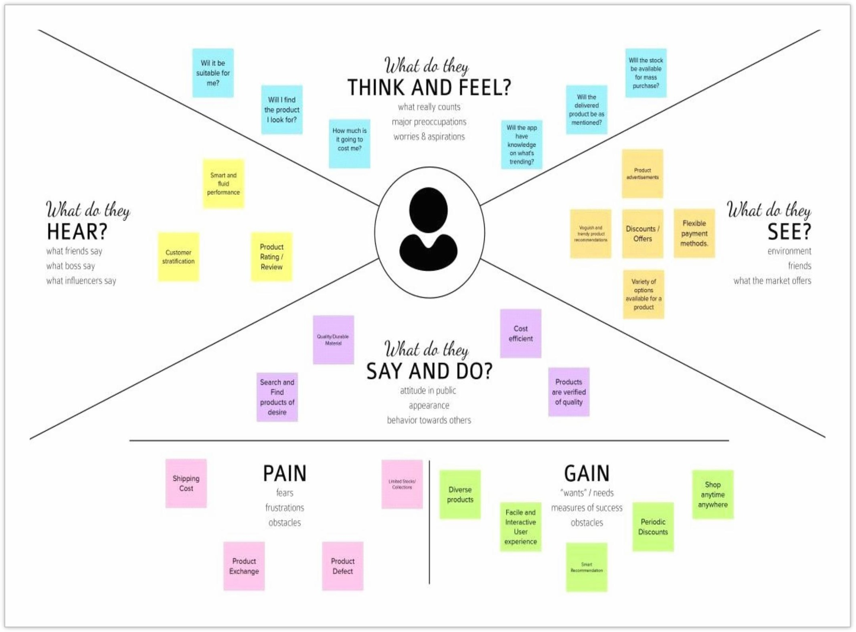Below, we have attached our empathy map to simulate our idea of the users’ perspective. Wehave listed what they think and feel, hear, see and say and do.

# Ideation & Brainstorming

**Step 1: Team Gathering, Collaboration and Select the Problem Statement**

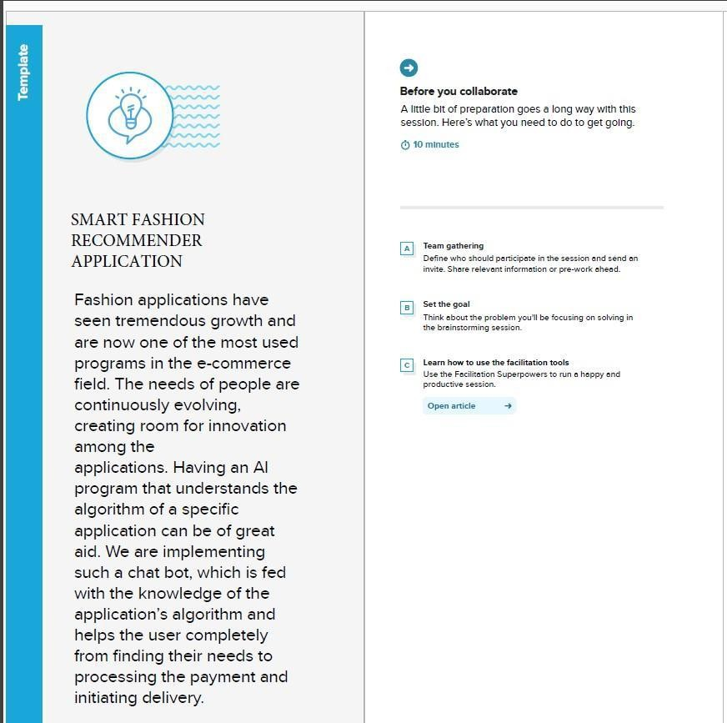

**Fig 3.2.1 Brainstorm & idea prioritization**

# Step 2: Brainstorm, Idea listing and Grouping

# 

**Fig 3.2.2 Idea Listing & Grouping**

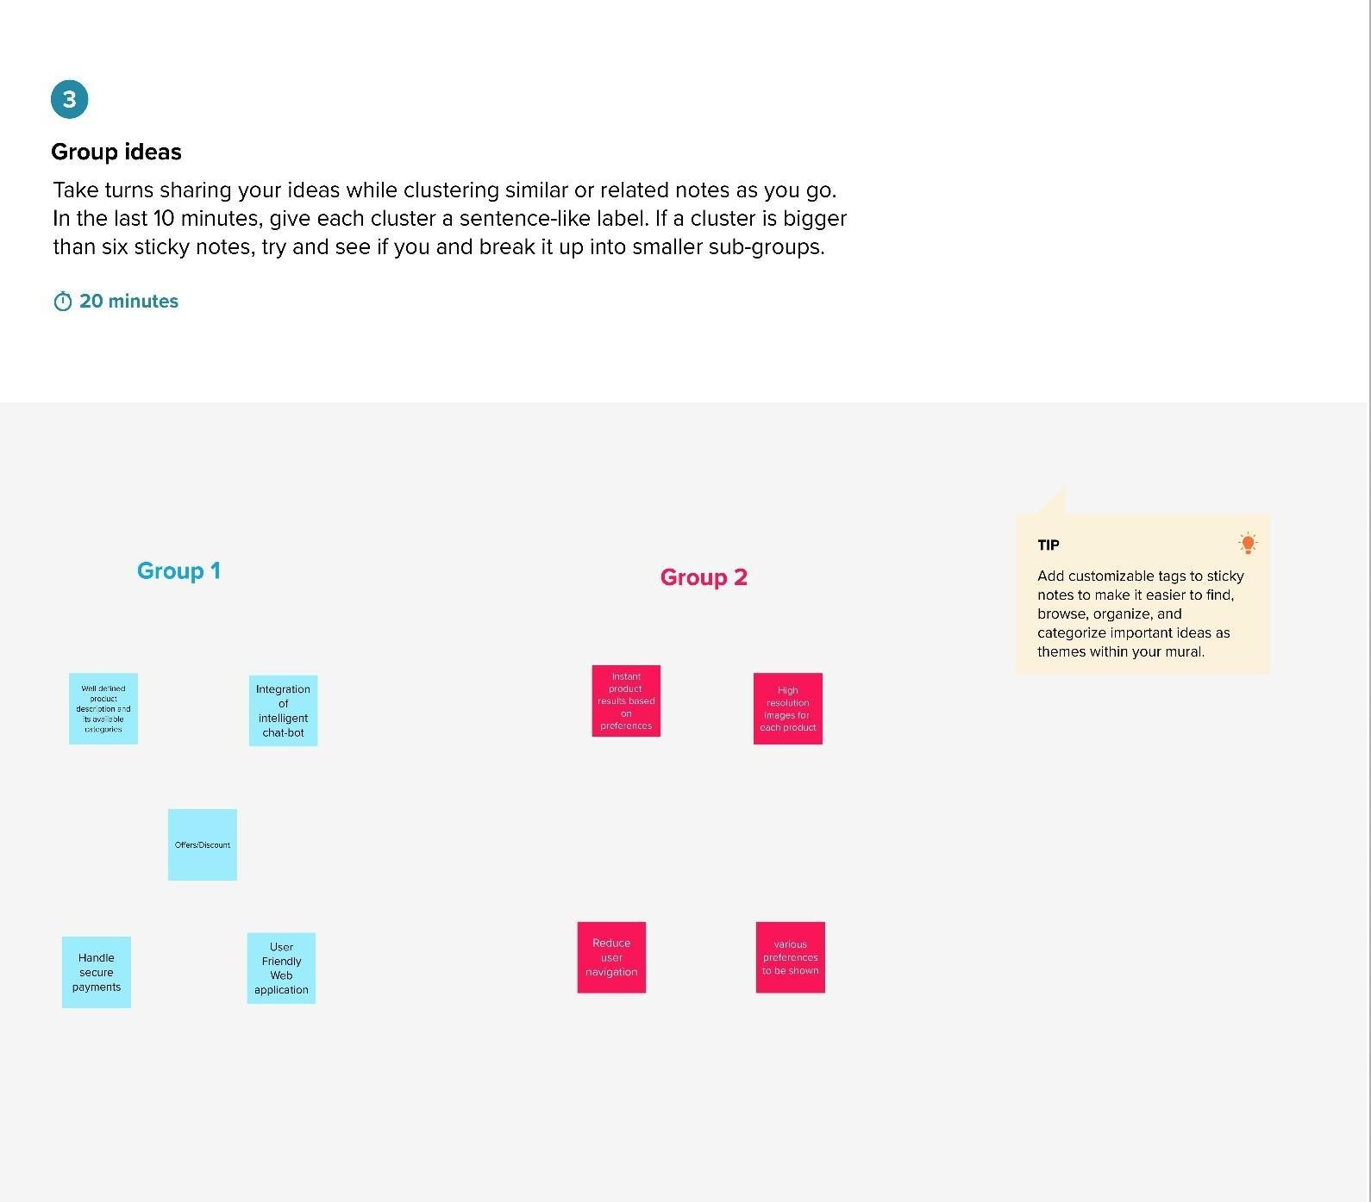

**Fig 3.2.3 Group Ideas**

# Step 3: Idea Prioritization

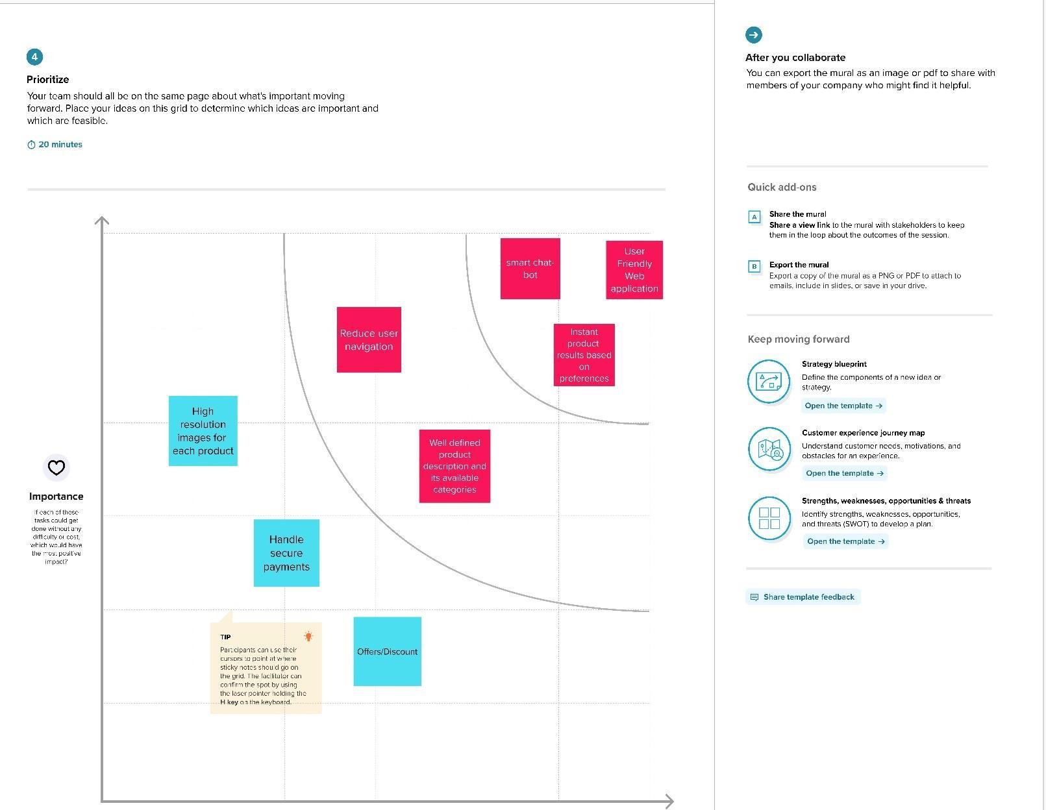

**Fig 3.2.4 Idea Prioritization**

# Proposed Solution

|  |  |  |
| --- | --- | --- |
| **S.No.** | **Parameter** | **Description** |
| 1. | Problem Statement (Problem tobe solved) | * Lack of interaction between application anduser * User need to navigate across multiple pages to choose right product * Confusion in choosing product * Lack of sales * Complex User Interface. * Lack of proper guidance. |
| 2. | Idea / Solution description | By using Smart fashion recommender application:   * Improve customer relationship, interactivityand services. * Effective recommendation of products. * Recommendation within a single page viachat- bot * Collect feedback instantly. * Reduce human error * Proper guidance in accessing application. |
| 3. | Novelty / Uniqueness | * Chat-bot asks and learns from user preferencewhich recommends appropriate products to the user without making them to search through various filters. Reduces time in choosing right product thus increases sales. |
| 4. | Social Impact / CustomerSatisfaction | * Feedback from the user at the end of session or after placing order is one of the most important factor in deriving customer satisfaction and providing better services. |
| 5. | Business Model (RevenueModel) | * The application can be developed at minimum cost with high performance and interactive user interface. |
| 6. | Scalability of the Solution | * The solution can be made scalable by usingmicro service architecture provided that each server responsible for certain functionality of the application. Storing user preferences along with product in browser cookie will enable to provide   response instantly and allows for fetching related products. |

* 1. **Problem Solution fit**

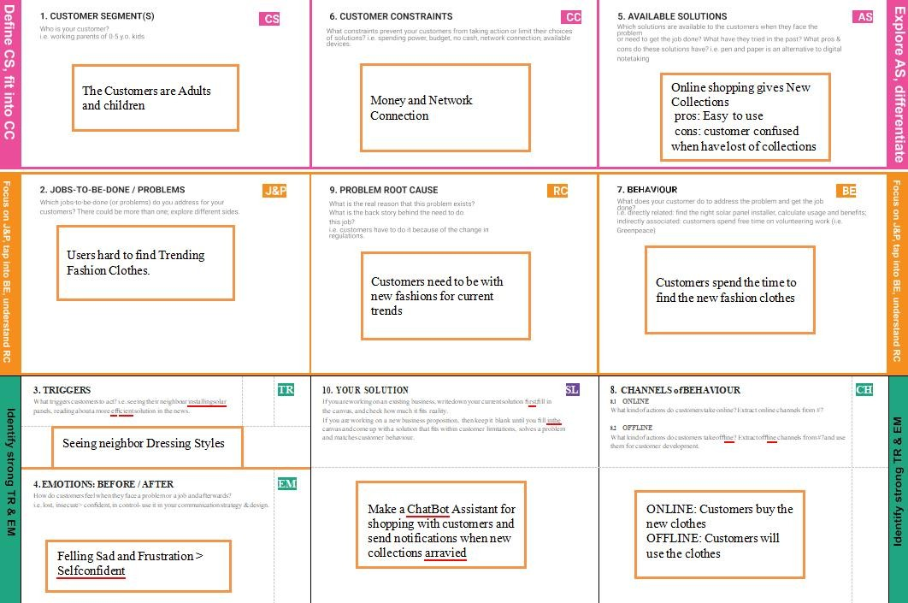

# REQUIREMENT ANALYSIS

* 1. **Functional Requirement**

Following are the functional requirements of the proposed solution.

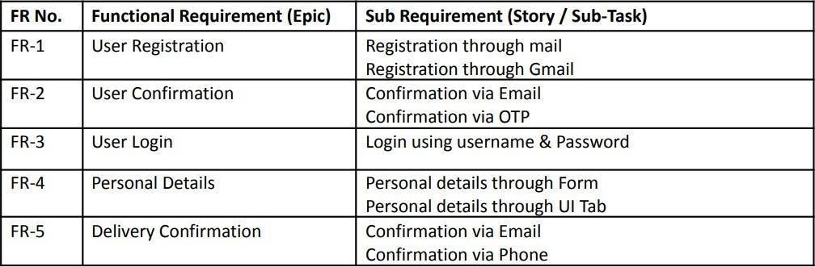

# Non-Functional Requirement

Following are the non-functional requirements of the proposed solution.

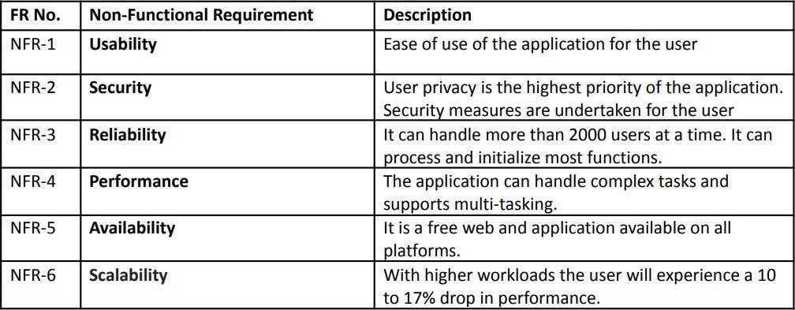

# PROJECT DESIGN

* 1. 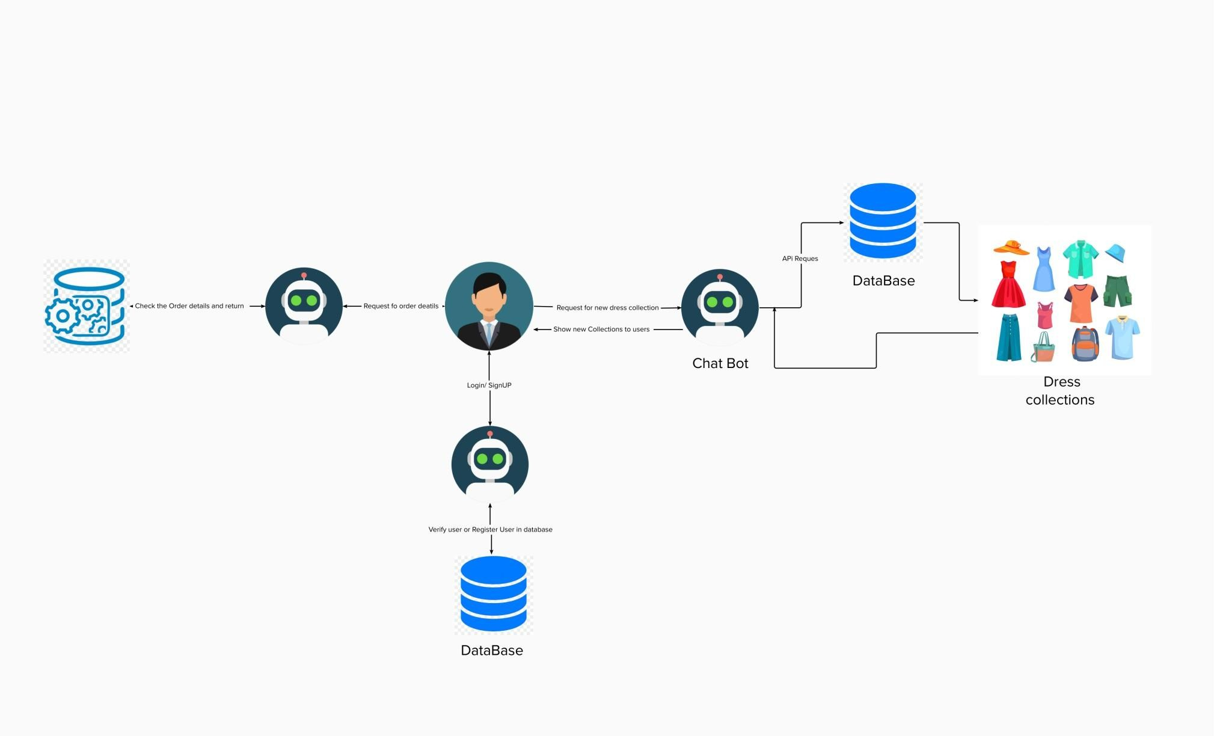**Data Flow Diagrams**

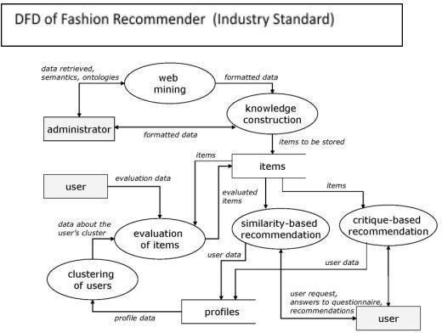

# Solution & Technical Architecture

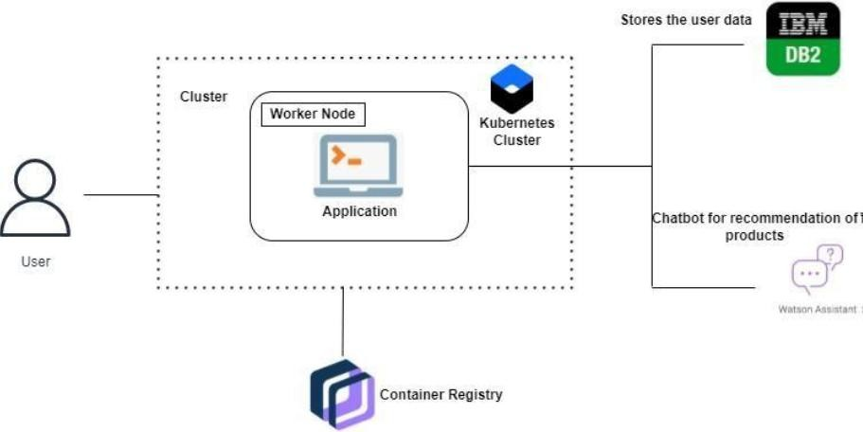

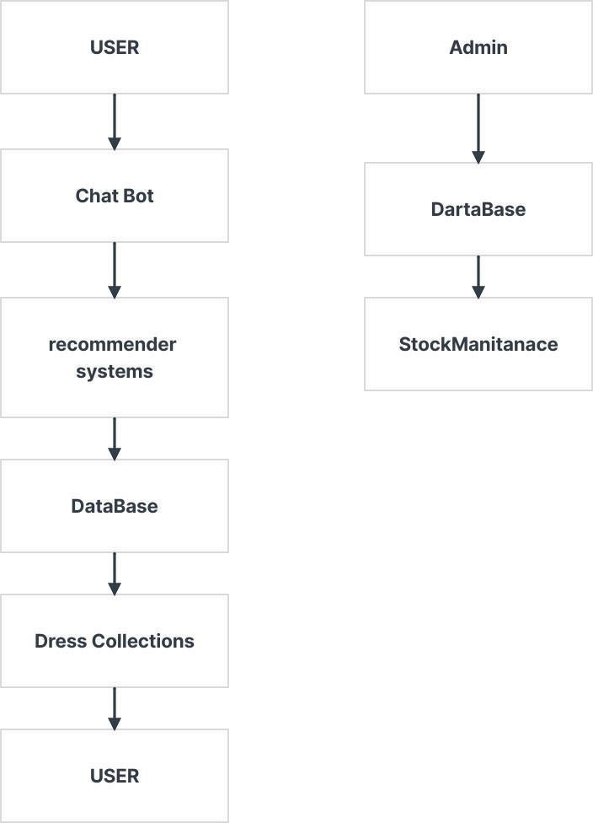

**Table-1 : Components & Technologies:**

|  |  |  |  |
| --- | --- | --- | --- |
| **S.No** | **Component** | **Description** | **Technology** |
| 1 | User Interface | user interaction with application e.g. Web UI & Chatbot | HTML, CSS,Bootstrap JavaScript |
| 2 | Application Logic | Logic for a process in the application | Python - Flask |
| 3 | Email Service | For verify user and mail ads | SendGrid |
| 4 | Chatbot | Get details from user and store | IBM Watson Assistant |
| 5 | Cloud Database | Database Service on Cloud | IBM DB2 |
| 6 | Infrastructure(Server/Client) | Application Deployment on Cloud System | Docker, Cloud Foundry, Kubernetes, etc. |

# Table-2: Application Characteristics

|  |  |  |  |
| --- | --- | --- | --- |
| **S.No** | **Characteristics** | **Description** | **Technology** |
| 1 | Open Source Frameworks | Used Web technologies | HTML , CSS , JS ,  Python , Flask |
| 2 | Security Infrastructure | User verification through Email Service | Sendgrid |
| 3 | Scalable Architecture | Run the app in Local and Cloud System | Docker and Kubernetes |
| 4 | Availability | Justify the availability of application (e.g. use of load balancers, distributed servers etc.) | Docker,IBM |
| 5 | Performance | Design consideration for the performance of the application (number of requests per sec, use of Cache, use of CDN’s) etc. | IBM Cloud , Kubernetes Cluster , Container Registry |

* 1. **User Stories**

## User Type Functional Requirement (Epic)

**User Story Number**

## User Story / Task Acceptance

**criteria**

## Priority Re

Customer(Mobile user)

Customer (Web user)

Customer Care Executive

Registration

Login

Dashboard

Registration /Login

Contact with Customers

USN-1

USN-2

USN-3

USN-4

USN-5

USN-6

USN-7

USN-8

As a user, I can register for the application by

entering my email, password, and confirming my password.

As a user, I will receive confirmation emailonce I have registered for the application

As a user, I can register for the application through Facebook

As a user, I can register for the application through Gmail

As a user, I can log into the application byentering email & password

As a user , I can view the dashboard and byproducts

As a user, I can register for the application by

entering my email, password, and confirming my password.

As a Customer customers care executive,I solve the customer Requirements and feedback

I can access my account / dashboard

I can receive confirmation email & click confirm

I can register & access the dashboard with Facebook Login

I can access my data by login

I can access my account / dashboard

I can receive calls from customers

High Sp 1

High Sp 1

Low Sp 2

Medium Sp

1

High Sp 1

High Sp

Sp 1

High Sp 1

Administrator

Stock and price order

USN-9

As a Administrator , I can Check the database And stock details and buying and selling prices

I am the administrator ofthe company

High Sp 1

# PROJECT PLANNING & SCHEDULING

* 1. **Sprint Planning & Estimation**

|  |  |  |  |  |  |  |
| --- | --- | --- | --- | --- | --- | --- |
| **Sprint** | **Functional Requirement (Epic)** | **User Story Number** | **User Story / Task** | **Story Points** | **Priority** | **Team Members** |
| Sprint-1 | User Panel | USN-1 | The user login into | 20 | High | MOHAN KUMAR S  ARUN S |

|  |  |  |  |  |  |  |
| --- | --- | --- | --- | --- | --- | --- |
|  |  |  | the website and go through the availability of products on it. |  |  | DHINAKARAN R S  KAVIN KUMAR M |
| Sprint-2 | Admin Panel | USN-2 | The role of the admin is to check out the database of the product stock and track all the things that the customers are purchasing. | 20 | High | MOHAN KUMAR S  ARUN S  DHINAKARAN R S  KAVIN KUMAR M |
| Sprint-3 | Chat Bot | USN-3 | The user can directly talk to Chatbot about the products. Get the recommendations based on the information provided by the users. | 20 | High | MOHAN KUMAR S  ARUN S  DHINAKARAN R S  KAVIN KUMAR M |
| Sprint-4 | Final delivery | USN-4 | Container of applications using kubernetes and deployment of the application. Create the documentaion and final submit the application. | 20 | High | MOHAN KUMAR S  ARUN S  DHINAKARAN R S  KAVIN KUMAR M |

# Sprint Delivery Schedule

|  |  |  |  |  |  |
| --- | --- | --- | --- | --- | --- |
| **Sprint** | **Total Story Points** | **Duration** | **Sprint Start Date** | **Sprint End Date (Planned** | **Sprint Release Date (Actual)** |

|  |  |  |  |  |  |
| --- | --- | --- | --- | --- | --- |
| Sprint-1 | 20 | 6 Days | 24 Oct 2022 | 29 Oct 2022 | 29 Oct 2022 |
| Sprint-2 | 20 | 6 Days | 31 Oct 2022 | 05 Nov  2022 | 05 Nov 2022 |
| Sprint-3 | 20 | 6 Days | 07 Nov  2022 | 12 Nov  2022 | 12 Nov 2022 |
| Sprint-4 | 20 | 6 Days | 14 Nov  2022 | 19 Nov  2022 | 19 Nov 2022 |

* 1. **Reports from JIRA**

## Burndown Chart:

A burn down chart is a graphical representation of work left to do versus time. It is often used in agile software development methodologies such as Scrum. However, burn down charts can be applied to any project containing measurable progress over time.

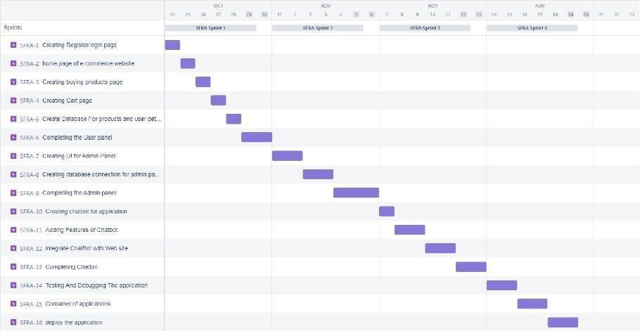

# CODING AND SOLUTIONING Feature 1

## Cart Page

<!DOCTYPE html>

<html lang="en">

<head>

<meta charset="UTF-8">

<meta http-equiv="X-UA-Compatible" content="IE=edge">

<meta name="viewport" content="width=device-width, initial-scale=1.0">

<title>Cart</title>

<link rel="stylesheet" href="https://cdnjs.cloudflare.com/ajax/libs/font-awesome/4.7.0/css/font- awesome.min.css">

<link rel="stylesheet" href="https://rakesh87.s3.us-east.cloud-object-storage.appdomain.cloud/style.css">

</head>

<body>

<section id="header">

<a href="#"><img src="https://saravanan2001mohan.s3.us-east.cloud-object- storage.appdomain.cloud/rst%20(1).png" class="logo" alt="" width="150" height="60"></a>

<div>

<ul id="navbar">

<li><a href="index.html">Home</a></li>

<li><a href="products.html">Products</a></li>

<li><a href="blog.html">Blog</a></li>

<li><a href="about.html">About</a></li>

<li><a href="contact.html">Contact</a></li>

<li><a class="active" href="cart.html"><i class="fa fa-shopping-bag"></i></a></li>

<li><a href="register.html"><i class="fa fa-user-secret"></i></a></li>

</ul>

</section>

<section id="page-header" class="about-header">

<h2>#Cart</h2>

<p>Add your coupon code & SAVE upto 70%!</p>

</section>

<section id="cart" class="section-p1">

<table width="100%">

<thead>

<tr>

<td>Remove</td>

<td>Image</td>

<td>Product</td>

<td>Price</td>

<td>Quantity</td>

<td>Subtotal</td>

</tr>

</thead>

<tbody>

<tr>

<td><i class=" fa fa-circle" ></i></td>

<td><img src=https://saravanan2001mohan.s3.us-east.cloud-object- storage.appdomain.cloud/jonathan-duran-n3lKeyUtkKA-unspl.jpg alt=""></td>

<td>Men's brown wallet</td>

<td>₹1000</td>

<td><input type="number" value="1"></td>

<td>₹1000</td>

</tr>

<tr>

<td><i class=" fa fa-circle" ></i></td>

<td><img src="https://saravanan2001mohan.s3.us-east.cloud-object- storage.appdomain.cloud/oo%20(1).jpg" alt=""></td>

<td>Men's hoodie jacket</td>

<td>₹1500</td>

<td><input type="number" value="1"></td>

<td>₹1500</td>

</tr>

<tr>

<td><i class=" fa fa-circle" ></i></td>

<td><img src="https://s3.jp-tok.cloud-object-storage.appdomain.cloud/unik/pro-shoe1.jpg" alt=""></td>

<td>Leather Shoe-Brown</td>

<td>₹9800</td>

<td><input type="number" value="1"></td>

<td>₹9800</td>

</tr>

</tbody>

</table>

</section>

<section id="cart-add" class="section-p1">

<div id="coupon">

<h3>Apply Coupon</h3>

<div>

<input type="text" placeholder="Enter your Coupon">

<button class="normal" >Apply</button>

</div>

</div>

<div id="subtotal">

<h3>Cart Total</h3>

<table>

<tr>

<td>Cart Subtotal</td>

<td>12300</td>

</tr>

<tr>

<td>Shipping</td>

<td>Free</td>

</tr>

<tr>

<td><strong>Total</strong></td>

<td><strong>12300</strong></td>

</tr>

</table><br>

<button class="normal">Proceed to checkout</button>

</div>

</section>

<footer class="section-p1">

<div class="col">

<img class="logo" src="https://saravanan2001mohan.s3.us-east.cloud-object- storage.appdomain.cloud/rst%20(1).png" alt="" width="200" height="100">

<h4>Contact</h4>

<p><strong>E-Mail: </strong>[rstsmartfashion@gmail.com](mailto:rstsmartfashion@gmail.com)</p>

<p><strong>Phone: </strong>1234567890</p>

<div class="follow">

<h4>Follow us</h4>

<div class="icon">

<i class="fa fa-facebook-f"></i>

<i class="fa fa-twitter"></i>

<i class="fa fa-instagram"></i>

<i class="fa fa-pinterest-p"></i>

<i class="fa fa-youtube"></i>

</div>

</div>

</div>

<div class="col">

<h4>About</h4>

<a href="#">About us</a>

<a href="#">Delivery Information</a>

<a href="#">Privacy Policy</a>

<a href="#">Tearms & Conditions</a>

<a href="#">Contact us</a>

</div>

<div class="col">

<h4>My Account</h4>

<a href="#">Sign In</a>

<a href="#">View Cart</a>

<a href="#">My Wishlist</a>

<a href="#">Track my order</a>

<a href="#">Help</a>

</div>

</footer>

<div class="copyright">

<center><p> C 2022, PNT2022TMID16242- Smart Fashion Recommender Application

</p></center>

</div>

<script src="script.js"></script>

</body>

</html>

## Index Page

<!DOCTYPE html>

<html lang="en">

<head>

<meta charset="UTF-8">

<meta http-equiv="X-UA-Compatible" content="IE=edge">

<meta name="viewport" content="width=device-width, initial-scale=1.0">

<title>RST/Home</title>

<link rel="stylesheet" href="https://cdnjs.cloudflare.com/ajax/libs/font-awesome/4.7.0/css/font- awesome.min.css">

<link rel="stylesheet" href="https://rakesh87.s3.us-east.cloud-object-storage.appdomain.cloud/style.css">

</head>

<body>

<section id="header">

<a href="#"><img src="https://saravanan2001mohan.s3.us-east.cloud-object- storage.appdomain.cloud/rst%20(1).png" class="logo" alt="" width="150" height="60"></a>

<div>

<ul id="navbar">

<li><a class="active" href="index.html">Home</a></li>

<li><a href="products.html">Products</a></li>

<li><a href="blog.html">Blog</a></li>

<li><a href="about.html">About</a></li>

<li><a href="contact.html">Contact</a></li>

<li><a href="cart.html"><i class="fa fa-shopping-bag"></i></a></li>

<li><a href="register.html"><i class="fa fa-user-secret"></i></a></li>

</ul>

</section>

<section id="hero">

<h4>"Happiness Depends Upon Ourselves"</h4>

<h2>Smart Fashion Recommender</h2>

<h1>Application</h1>

<p>Dress Up In Confidence</p>

<button class="normal">Shop now</button>

</section>

<section id="feature" class="section-p1">

<div class="fe-box">

<img src="https://unik.s3.jp-tok.cloud-object-storage.appdomain.cloud/freeship.png" alt="" width="100" height="100">

<h6>Free Shipping</h6>

</div>

<div class="fe-box">

<img src="https://unik.s3.jp-tok.cloud-object-storage.appdomain.cloud/orderonline.jpg" alt="" width="100" height="100">

<h6>Online Order</h6>

</div>

<div class="fe-box">

<img src="https://unik.s3.jp-tok.cloud-object-storage.appdomain.cloud/savemoney.jpg" alt="" width="100" height="100">

<h6>Save Money</h6>

</div>

<div class="fe-box">

<img src="https://unik.s3.jp-tok.cloud-object-storage.appdomain.cloud/promotion.jpg" alt="" width="100" height="100">

<h6>Promotions</h6>

</div>

<div class="fe-box">

<img src="https://unik.s3.jp-tok.cloud-object-storage.appdomain.cloud/happysell.jpg" alt="" width="100" height="100">

<h6>Happy Sell</h6>

</div>

<div class="fe-box">

<img src="https://unik.s3.jp-tok.cloud-object-storage.appdomain.cloud/support.jpg" alt="" width="100" height="100">

<h6>F24/7 Support</h6>

</div>

</section>

<section id="product1" class="section-p1">

<h2>Featured Product</h2>

<p>New Collections New Modern Designs</p>

<div class="pro-container">

<div class="pro">

<img src="https://unik.s3.jp-tok.cloud-object-storage.appdomain.cloud/shopshirt1.jpg" alt="" >

<div class="des">

<span>Attitude</span>

<h5>Blue n Brown T-Shirts</h5>

<div class="star">

<i class="fa fa-star"></i>

<i class="fa fa-star"></i>

<i class="fa fa-star"></i>

<i class="fa fa-star"></i>

<i class="fa fa-star"></i>

</div>

<h4>₹1500</h4>

</div>

<a href="#"><i class="fa fa-shopping-bag bag"></i></a>

</div>

<div class="pro">

<img src="https://unik.s3.jp-tok.cloud-object-storage.appdomain.cloud/shopshirt2.jpg" alt="">

<div class="des">

<span>U.S.Polo Assnn</span>

<h5>Blue strip T-Shirts</h5>

<div class="star">

<i class="fa fa-star"></i>

<i class="fa fa-star"></i>

<i class="fa fa-star"></i>

<i class="fa fa-star"></i>

<i class="fa fa-star"></i>

</div>

<h4>₹1570</h4>

</div>

<a href="#"><i class="fa fa-shopping-bag bag"></i></a>

</div>

<div class="pro">

<img src="https://unik.s3.jp-tok.cloud-object-storage.appdomain.cloud/shopshirt3.jpg" alt="">

<div class="des">

<span>Zara</span>

<h5>Plain T-Shirts</h5>

<div class="star">

<i class="fa fa-star"></i>

<i class="fa fa-star"></i>

<i class="fa fa-star"></i>

<i class="fa fa-star"></i>

<i class="fa fa-star"></i>

</div>

<h4>₹1400</h4>

</div>

<a href="#"><i class="fa fa-shopping-bag bag"></i></a>

</div>

<div class="pro">

<img src="https://unik.s3.jp-tok.cloud-object-storage.appdomain.cloud/home5.jpg" alt="">

<div class="des">

<span>Ruralking</span>

<h5>Checked T-Shirts</h5>

<div class="star">

<i class="fa fa-star"></i>

<i class="fa fa-star"></i>

<i class="fa fa-star"></i>

<i class="fa fa-star"></i>

<i class="fa fa-star"></i>

</div>

<h4>₹2000</h4>

</div>

<a href="#"><i class="fa fa-shopping-bag bag"></i></a>

</div>

<div class="pro">

<img src="https://s3.jp-tok.cloud-object-storage.appdomain.cloud/unik/saree.jpg" alt="">

<div class="des">

<span>Banarasi</span>

<h5>Georgette Bandhani Rama Blue & Olive Green Saree</h5>

<div class="star">

<i class="fa fa-star"></i>

<i class="fa fa-star"></i>

<i class="fa fa-star"></i>

<i class="fa fa-star"></i>

<i class="fa fa-star"></i>

</div>

<h4>₹10,000</h4>

</div>

<a href="#"><i class="fa fa-shopping-bag bag"></i></a>

</div>

<div class="pro">

<img src="https://s3.jp-tok.cloud-object-storage.appdomain.cloud/unik/saree1.jpg" alt="">

<div class="des">

<span>Banarasi</span>

<h5>Banarasi Silk Jaal Dark Maroon Saree</h5>

<div class="star">

<i class="fa fa-star"></i>

<i class="fa fa-star"></i>

<i class="fa fa-star"></i>

<i class="fa fa-star"></i>

<i class="fa fa-star"></i>

</div>

<h4>₹9000</h4>

</div>

<a href="#"><i class="fa fa-shopping-bag bag"></i></a>

</div>

<div class="pro">

<img src="https://s3.jp-tok.cloud-object-storage.appdomain.cloud/unik/saree2.jpg" alt="">

<div class="des">

<span>Banarasi</span>

<h5>Banarasi Silk Buttis Yellow Saree</h5><br>

<div class="star">

<i class="fa fa-star"></i>

<i class="fa fa-star"></i>

<i class="fa fa-star"></i>

<i class="fa fa-star"></i>

<i class="fa fa-star"></i>

</div>

<h4>₹8000</h4>

</div>

<a href="#"><i class="fa fa-shopping-bag bag"></i></a>

</div>

<div class="pro">

<img src="https://s3.jp-tok.cloud-object-storage.appdomain.cloud/unik/saree3.jpg" alt="">

<div class="des">

<span>Banarasi</span>

<h5>Banarasi Silk Jaal Purple Saree</h5><br>

<div class="star">

<i class="fa fa-star"></i>

<i class="fa fa-star"></i>

<i class="fa fa-star"></i>

<i class="fa fa-star"></i>

<i class="fa fa-star"></i>

</div>

<h4>₹6000</h4>

</div>

<a href="#"><i class="fa fa-shopping-bag bag"></i></a>

</div>

</div>

</section>

<section id="banner" class="section-m1">

<h4>Repair Services</h4>

<h2>Up to <span>70% off</span> All t-Shirts & Accessories</h2>

<a href="products.html"><button class="normal">Explore More</button></a>

</section>

<section id="product1" class="section-p1">

<h2>New Arrivals</h2>

<p>Branded shoe's and T-shirts </p>

<div class="pro-container">

<div class="pro">

<img src="https://s3.jp-tok.cloud-object-storage.appdomain.cloud/unik/shoe.jpg" height="400"

alt="" >

<div class="des">

<span>adidas</span>

<h5>Blue Shoe</h5>

<div class="star">

<i class="fa fa-star"></i>

<i class="fa fa-star"></i>

<i class="fa fa-star"></i>

<i class="fa fa-star"></i>

<i class="fa fa-star"></i>

</div>

<h4>₹6000</h4>

</div>

<a href="#"><i class="fa fa-shopping-bag bag"></i></a>

</div>

<div class="pro">

alt="">

alt="">

<img src="https://s3.jp-tok.cloud-object-storage.appdomain.cloud/unik/shoe1.jpg" height="400"

<div class="des">

<span>Bata</span>

<h5>Brown leather shoe</h5>

<div class="star">

<i class="fa fa-star"></i>

<i class="fa fa-star"></i>

<i class="fa fa-star"></i>

<i class="fa fa-star"></i>

<i class="fa fa-star"></i>

</div>

<h4>₹8000</h4>

</div>

<a href="#"><i class="fa fa-shopping-bag bag"></i></a>

</div>

<div class="pro">

<img src="https://s3.jp-tok.cloud-object-storage.appdomain.cloud/unik/shoe2.jpg" height="400"

<div class="des">

<span>Nike</span>

<h5>Sandle High Heel</h5>

<div class="star">

<i class="fa fa-star"></i>

<i class="fa fa-star"></i>

<i class="fa fa-star"></i>

<i class="fa fa-star"></i>

<i class="fa fa-star"></i>

</div>

<h4>₹6600</h4>

</div>

<a href="#"><i class="fa fa-shopping-bag bag"></i></a>

</div>

alt="">

<div class="pro">

<img src="https://s3.jp-tok.cloud-object-storage.appdomain.cloud/unik/shoe3.jpg" height="400"

<div class="des">

<span>Walkaroo</span>

<h5>Brown High Heel</h5>

<div class="star">

<i class="fa fa-star"></i>

<i class="fa fa-star"></i>

<i class="fa fa-star"></i>

<i class="fa fa-star"></i>

<i class="fa fa-star"></i>

</div>

<h4>₹7800</h4>

</div>

<a href="#"><i class="fa fa-shopping-bag bag"></i></a>

</div>

<div class="pro">

<img src="https://s3.jp-tok.cloud-object-storage.appdomain.cloud/unik/tops.jpg" alt="">

<div class="des">

<span>Zara</span>

<h5>Black Smile T-Shirts</h5>

<div class="star">

<i class="fa fa-star"></i>

<i class="fa fa-star"></i>

<i class="fa fa-star"></i>

<i class="fa fa-star"></i>

<i class="fa fa-star"></i>

</div>

<h4>₹900</h4>

</div>

<a href="#"><i class="fa fa-shopping-bag bag"></i></a>

</div>

<div class="pro">

<img src="https://s3.jp-tok.cloud-object-storage.appdomain.cloud/unik/tops1.jpg" alt="">

<div class="des">

<span>Zara</span>

<h5>Pink dog T-Shirts</h5>

<div class="star">

<i class="fa fa-star"></i>

<i class="fa fa-star"></i>

<i class="fa fa-star"></i>

<i class="fa fa-star"></i>

<i class="fa fa-star"></i>

</div>

<h4>₹900</h4>

</div>

<a href="#"><i class="fa fa-shopping-bag bag"></i></a>

</div>

<div class="pro">

<img src="https://s3.jp-tok.cloud-object-storage.appdomain.cloud/unik/tops2.jpg" alt="">

<div class="des">

<span>Zara</span>

<h5>Black and White Trendy Shirt</h5>

<div class="star">

<i class="fa fa-star"></i>

<i class="fa fa-star"></i>

<i class="fa fa-star"></i>

<i class="fa fa-star"></i>

<i class="fa fa-star"></i>

</div>

<h4>₹1500</h4>

</div>

<a href="#"><i class="fa fa-shopping-bag bag"></i></a>

</div>

</div>

<div class="pro">

<img src="https://s3.jp-tok.cloud-object-storage.appdomain.cloud/unik/tops3.jpg" alt="">

<div class="des">

<span>Zara</span>

<h5>Green Panda Shirt</h5>

<div class="star">

<i class="fa fa-star"></i>

<i class="fa fa-star"></i>

<i class="fa fa-star"></i>

<i class="fa fa-star"></i>

<i class="fa fa-star"></i>

</div>

<h4>₹600</h4>

</div>

<a href="#"><i class="fa fa-shopping-bag bag"></i></a>

</div>

</section>

<section id="sm-banner" class="section-p1">

<div class="banner-box">

<h4>Crazy Deals</h4>

<h2>Buy 1 get 1 free</h2>

<span>The best classic dress is on sale at U Nik</span>

<a href="products.html"><button class="white">Learn More </button></a>

</div>

<div class="banner-box banner-box2">

<h4>spring/summer</h4>

<h2>upcommig seasons</h2>

<span>The best classic dress is on sale at U Nik</span>

<a href="blog.html"><button class="white">Collection</button></a>

</div >

</section>

<section id="banner3">

<div class="banner-box">

<h2>SEASONAL SALE</h2>

<h3>Winter collection 50% off</h3>

</div >

<div class="banner-box banner-box2">

<h2>SEASONAL SALE</h2>

<h3>Winter collection 50% off</h3>

</div >

<div class="banner-box banner-box3">

<h2>SEASONAL SALE</h2>

<h3>Winter collection 50% off</h3>

</div >

</section>

<section id="newsletter" class="section-p1">

<div class="newstext">

<h4>Sign up for NewsLetters</h4>

<p>Get Email updates about our latest shop and <span>special offer</span>

</p>

</div>

<div class="form">

<input type="text" placeholder="Your E-mail Address">

<button class="normal">Sign Up</button>

</div>

</section>

<footer class="section-p1">

<div class="col">

<img class="logo" src="https://saravanan2001mohan.s3.us-east.cloud-object- storage.appdomain.cloud/rst%20(1).png" alt="" width="200" height="100">

<h4>Contact</h4>

<p><strong>E-Mail: </strong>[rstsmartfashion@gmail.com](mailto:rstsmartfashion@gmail.com)</p>

<p><strong>Phone: </strong>1234567890</p>

<div class="follow">

<h4>Follow us</h4>

<div class="icon">

<i class="fa fa-facebook-f"></i>

<i class="fa fa-twitter"></i>

<i class="fa fa-instagram"></i>

<i class="fa fa-pinterest-p"></i>

<i class="fa fa-youtube"></i>

</div>

</div>

</div>

<div class="col">

<h4>About</h4>

<a href="#">About us</a>

<a href="#">Delivery Information</a>

<a href="#">Privacy Policy</a>

<a href="#">Tearms & Conditions</a>

<a href="#">Contact us</a>

</div>

<div class="col">

<h4>My Account</h4>

<a href="#">Sign In</a>

<a href="#">View Cart</a>

<a href="#">My Wishlist</a>

<a href="#">Track my order</a>

<a href="#">Help</a>

</div>

</footer>

<div class="copyright">

<center><p>© 2022, PNT2022TMID16242 - Smart Fashion Recommender Application

</p></center>

</div>

<script src="script.js"></script>

</body>

</html>

## Login Page

<!DOCTYPE html>

<html lang="en">

<head>

<meta charset="UTF-8">

<meta http-equiv="X-UA-Compatible" content="IE=edge">

<meta name="viewport" content="width=device-width, initial-scale=1.0">

<title>Login</title>

<link rel="stylesheet" href="https://cdnjs.cloudflare.com/ajax/libs/font-awesome/4.7.0/css/font- awesome.min.css">

<link rel="stylesheet" href="https://rakesh87.s3.us-east.cloud-object-storage.appdomain.cloud/style.css">

</head>

<body>

<section id="header">

<a href="#"><img src="https://saravanan2001mohan.s3.us-east.cloud-object- storage.appdomain.cloud/rst%20(1).png" class="logo" alt="" width="150" height="60"></a>

<div>

<ul id="navbar">

<li><a class="active" href="index.html">Home</a></li>

<li><a href="products.html">Products</a></li>

<li><a href="blog.html">Blog</a></li>

<li><a href="about.html">About</a></li>

<li><a href="contact.html">Contact</a></li>

<li><a href="cart.html"><i class="fa fa-shopping-bag"></i></a></li>

<li><a href="cart.html"><i class="fa fa-user-secret"></i></a></li>

</ul>

</section>

<section id="login">

<form>

<div class="imgcontainer">

<h2>User Login</h2>

<img src="https://saravanan2001mohan.s3.us-east.cloud-object-storage.appdomain.cloud/alyssa- strohmann-TS--uNw-JqE-unsplash%20(1).jpg" alt="Avatar" width="200" height="300" class="avatar">

</div>

<div class="container">

<label for="mailid"><b>E-Mail</b></label>

<input type="text" placeholder="Enter your E-Mail" name="email" required>

<label for="psw"><b>Password</b></label>

<input type="password" placeholder="Enter Password" name="psw" required>

<button type="submit">Login</button>

<label>

<input type="checkbox" checked="checked" name="remember"> Remember me

</label>

</div>

<div class="container signin">

<p>Forget Password <a href="#"> Click here </a>.</p>

</div>

</form>

</section>

<footer class="section-p1">

<div class="col">

<img class="logo" src="https://saravanan2001mohan.s3.us-east.cloud-object- storage.appdomain.cloud/rst%20(1).png" alt="" width="200" height="100">

<h4>Contact</h4>

<p><strong>E-Mail: </strong>[rstsmartfashion007@gmail.com](mailto:rstsmartfashion007@gmail.com)</p>

<p><strong>Phone: </strong>1234567890</p>

<div class="follow">

<h4>Follow us</h4>

<div class="icon">

<i class="fa fa-facebook-f"></i>

<i class="fa fa-twitter"></i>

<i class="fa fa-instagram"></i>

<i class="fa fa-pinterest-p"></i>

<i class="fa fa-youtube"></i>

</div>

</div>

</div>

<div class="col">

<h4>About</h4>

<a href="#">About us</a>

<a href="#">Delivery Information</a>

<a href="#">Privacy Policy</a>

<a href="#">Tearms & Conditions</a>

<a href="#">Contact us</a>

</div>

<div class="col">

<h4>My Account</h4>

<a href="#">Sign In</a>

<a href="#">View Cart</a>

<a href="#">My Wishlist</a>

<a href="#">Track my order</a>

<a href="#">Help</a>

</div>

</footer>

<div class="copyright">

<center><p> C 2022, PNT2022TMID16242 - Smart Fashion Recommender Application

</p></center>

</div>

<script src="script.js"></script>

</body>

</html>

# TESTING

* 1. **Test Cases**

A test case is a set of actions performed on a system to determine if it satisfies software requirements and functions correctly. The purpose of a test case is to determine if different features within a system are performing as expected and to confirm that the system satisfies all related standards, guidelines and customer requirements. The process of writing a test case can also help reveal errors or defects within the system. Test cases are typically written by members of the quality assurance (QA) team or the testing team and can be used as step-by-step instructions for each system test. Testing begins once the development team has finished a system feature or set of features. A sequence or collection of test cases is called a test suite. A test case document includes test steps, test data, preconditions and the post conditions that verify requirements.

# Why test cases are important:

Test cases define what must be done to test a system, including the steps executed in the system, the input data values that are entered into the system and the results that are expected throughout test case execution. Using test cases allows developers and testers to discover errors that may have occurred during development or defects that were missed during ad hoc tests.

The benefits of an effective test case include:

* Guaranteed good test coverage.
* Reduced maintenance and software support costs.
* Reusable test cases.
* Confirmation that the software satisfies end-user requirements.
* Improved quality of software and user experience.
* Higher quality products lead to more satisfied customers.
* More satisfied customers will increase company profits.

Overall, writing and using test cases will lead to business optimization. Clients are more satisfied, customer retention increases, the costs of customer service and fixing products decreases, and more reliable products are produced, which improves the company's reputation and brand image.

# User Acceptance Testing

User acceptance testing (UAT), also called application testing or end-user testing, is a phase of software development in which the software is tested in the real world by its intended audience. User Acceptance Testing (UAT) is a type of testing performed by the end user or the client to verify/accept the software system before moving the software application to the production environment. UAT is done in the final phase of testing after functional, integration and system testing is done.

UAT testing meaning can also be defined as the user methodology where the developed software is tested by the business user to validate if the software is working as per the specifications defined. This type of testing is also known as beta testing, application testing, or more commonly end-user testing. The main **Purpose of UAT** is to validate end to end business flow. It does not focus on cosmetic errors, spelling mistakes or system testing. User Acceptance Testing is carried out in a separate testing environment with production-like data setup. It is kind of black box testing where two or more end- users will be involved.

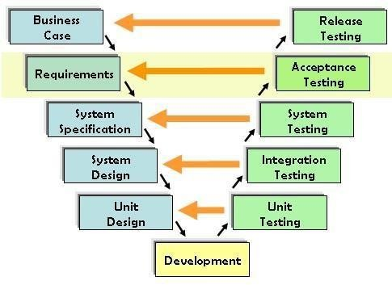

## 8.2Testing architecture

UAT is performed by:

* Client
* End users

## Need of User Acceptance Testing:

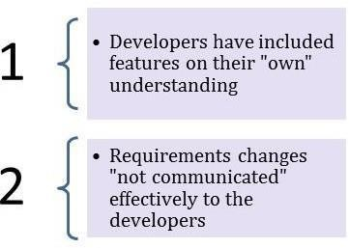Need of User Acceptance Testing arises once software has undergone Unit, Integration and System testing because developers might have built software based on requirements document by their own understanding and further required changes during development may not be effectively communicated to them, so for testing whether the final product is accepted by client/end-user, user acceptance testing is needed.

* Developers code software based on requirements document which is their “own” understanding of the requirements and **may not actually be what the client needs from the software**.
* Requirements changes during the course of the project may not be communicated effectively to the developers.

## Prerequisites of User Acceptance Testing:

Following are the entry criteria for User Acceptance Testing:

Business Requirements must be available.

* Application Code should be fully developed
* Unit Testing, Integration Testing & System Testing should be completed
* No Showstoppers, High, Medium defects in System Integration Test Phase –
* Only Cosmetic error is acceptable before UAT
* Regression Testing should be completed with no major defects
* All the reported defects should be fixed and tested before UAT
* Traceability matrix for all testing should be completed
* UAT Environment must be ready
* Sign off mail or communication from System Testing Team that the system is ready for UAT execution.

# RESULT

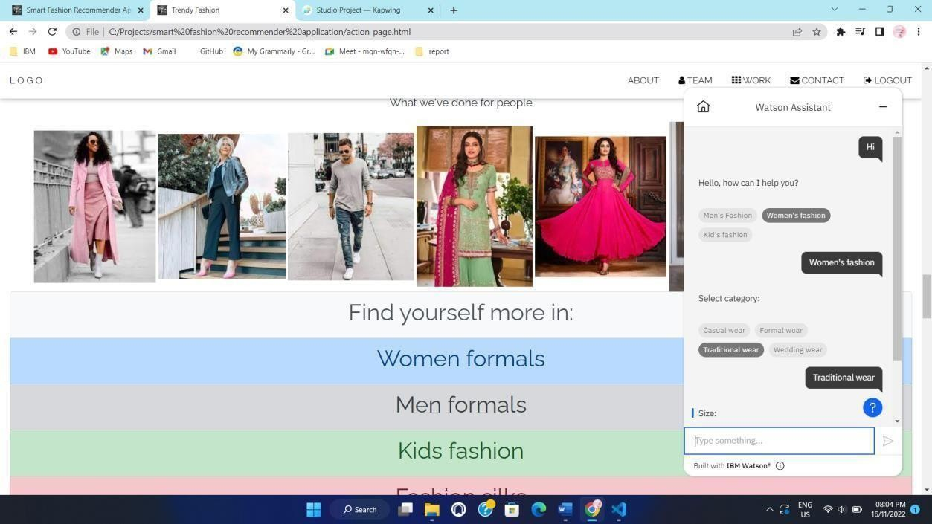

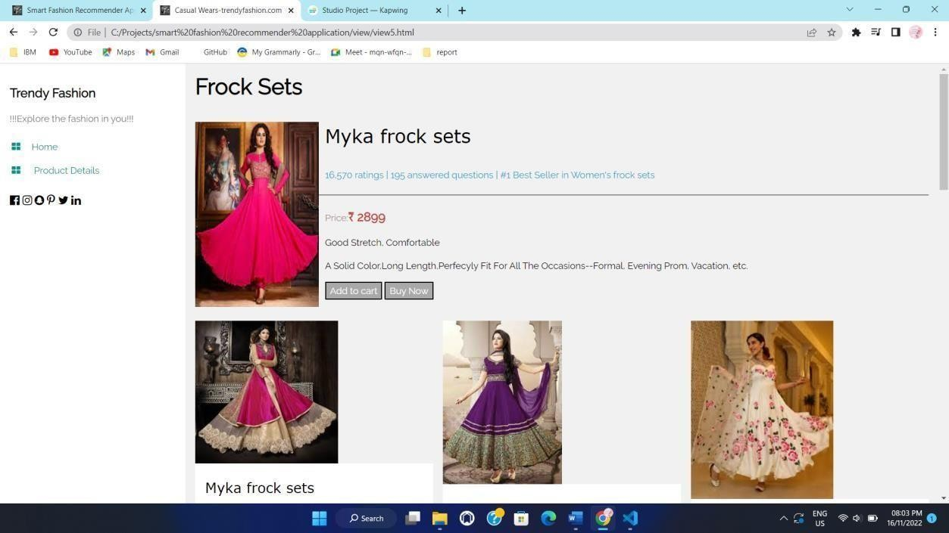

**9.1. Performance metrics:**

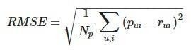The performance of a recommendation algorithm is evaluated by using some specific metrics that indicate the accuracy of the system. The type of metric used depends on the type of filtering technique. Root Mean Square Error (RMSE), Receiver Operating Characteristics (ROC), Area Under Cover (AUC), Precision, Recall, and F1 score is generally used to evaluate the performance or accuracy of the recommendation algorithms. Root-mean-square error (RMSE). RMSE is widely used in evaluating and comparing the performance of a recommendation system model compared to models. A lower RMSE value indicates higher performance by the recommendation model. RMSE, as mentioned can be as represented as follows:

Where Np is the total number of predictions, pui is the predicted rating that a user u will select item i, and rui is the real rating.

**Precision.** Precision can be defined as the fraction of correct recommendations or predictions (known as True Positive) to the total number of recommendations provided, which can be as represented as follows:

Precision=True Positive (TP)/True Positive(TP)+False Positive (FP)

It is also defined as the ratio of the number of relevant recommended items to the number of recommended items expressed as percentages.

**Recall**. Recall can be defined as the fraction of correct recommendations or predictions (known as True Positive) to the total number of correct relevant recommendations provided, which can be as represented as follows:

Recall=True Positive (TP) / True Positive(TP)+False Negative (FN)

It is also defined as the ratio of the number of relevant recommended items to the total number of relevant items expressed as percentages.

**F1 Score**. The F1 score is an indicator of the accuracy of the model and ranges from 0 to 1, where a value close to 1 represents a higher recommendation or prediction accuracy. It represents precision and recall as a single metric and can be as represented as follows:

F1 score=2×Precision Recall / Precision+Recalls

**Coverage.** Coverage is used to measure the percentage of items that are recommended by the algorithm among all of the items.

**Accuracy.** Accuracy can be defined as the ratio of the number of total correct recommendations to the total recommendations provided, which can be as represented as follows:

Accuracy=TP+FN / TP+FN+TN+FP

**Intersection over union (IoU).** It represents the accuracy of an object detector used on a specific dataset IoU=TP / TP+FN+FP 69

**ROC**.The ROC curve is used to conduct a comprehensive assessment of the algorithm’s performance.

**AUC.** AUC measures the performance of the recommendation and its baselines as well as the quality of the ranking based on pairwise comparisons. Rank aware top-N metrics. The rank-aware top-N recommendation metric finds some of the interesting and unknown items that are presumed to be most attractive to a user.

Mean reciprocal rank (MRR), mean average precision (MAP), and normalized discounted cumulative gain (NDCG) are the three most popular rank-aware metrics.

# ADVANTAGES AND DISADVANTAGES Advantages

* Build self-confidence and poise.
* Develop skills in planning, selecting, and making clothing for different occasions.
* Select appropriate accessories
* Develop good posture, grooming, and punctuality habits.
* Complete applications clearly and submit them on time.
* Acquire knowledge and skills in planning, presenting, and participating in fashion revues.
* To introduce the member and his/her project.
* To focus on skills learned in the clothing and textile project.
* To express challenges, fashion trends, and cost savings.
* To interest the audience in 4-H activities.
* To display the garment attractively.

# Disadvantages

* That is why smart fashion technology needs to take into consideration not only how it makes consumers feel, but what it does for their bodies.
* The high cost of energy.
* One of the main challenges faced in producing smart fashion accessories the negative environmental impact of the production process and the high cost of electricity in manufacturing these smart clothes.
* While top energy companies are working hard to reduce waste and reduce their energy consumption, smart accessories will only add to waste and energy usage.

## Skin Problem

* While there’s no major report about getting skin infection because of heavy use of smart fashion, there’s a chance of negative impacts of this wearable tech is poory designed.

## Smart clothes are expensive

* Smart clothing technology is still in the infancy stage, and not many companies are producing this smart fabric on a large scale because of the production cost that’s huge, therefore, not affordable for everyone at the moment

# CONCLUSION

In this project, we have presented a novel framework for fashion recommendation that is driven by data, visually related and simple effective recommendation systems for generating fashion product images. The proposed approach uses a two-stage phase. Initially, our proposed approach extracts the features of the image using CNN classifier ie., for instance allowing the customers to upload any random fashion image from any E-commerce website and later generating similar images to the uploaded image based on the features and texture of the input image. It is imperative that such research goes forward to facilitate greater recommendation accuracy and improve the overall experience of fashion exploration for direct and indirect consumers alike.

# FUTURE SCOPE

* Nowadays, fashion applications and e-commerce are growing more and more.And it also has some problems when finding the customer's wanted product in the web applications.
* Having a chatbot that understands the algorithm of a specific application can be of great aid. We are implementing such a chat bot in a web application, which is fed with the knowledge of the application’s algorithm and helps the user completely from finding their needs to processing the payment and initiating delivery.
* It works as an advanced filter search that can bring the user what they want with the help of pictorial and named representation by getting simple user information and activities.
* The application also has two main UI interactions: one is the user panel and the other one is the admin panel.
* Users can interact with the chat bot to search for products, order them from the manufacturer or distributor through chatbot AI, and it can also make payment transactions, track the delivery, and so on.
* The admin interface enables the user to upload products' details ,user details, orders and find how many products have been bought; supervise the stock availability; and interact with the buyer regarding the product reviews.

# 13 . APPENDIX

**Product.html**

<!DOCTYPE html>

<html lang="en">

<head>

<meta charset="UTF-8">

<meta http-equiv="X-UA-Compatible" content="IE=edge">

<meta name="viewport" content="width=device-width, initial-scale=1.0">

<title>Product</title>

<link rel="stylesheet" href="https://cdnjs.cloudflare.com/ajax/libs/font-awesome/4.7.0/css/font- awesome.min.css">

<link rel="stylesheet" href="https://rakesh87.s3.us-east.cloud-object-storage.appdomain.cloud/style.css">

</head>

<body>

<section id="header">

<a href="#"><img src="https://saravanan2001mohan.s3.us-east.cloud-object- storage.appdomain.cloud/rst%20(1).png" class="logo" alt="" width="150" height="60"></a>

<div>

<ul id="navbar">

<li><a href="index.html">Home</a></li>

<li><a class="active" href="products.html">Products</a></li>

<li><a href="blog.html">Blog</a></li>

<li><a href="about.html">About</a></li>

<li><a href="contact.html">Contact</a></li>

<li><a href="cart.html"><i class="fa fa-shopping-bag"></i></a></li>

<li><a href="cart.html"><i class="fa fa-user-secret"></i></a></li>

</ul>

</section>

<section id="page-header">

<h2>Kindness Always Come Back</h2>

<p>Save more with coupons & up to 70% off</p>

</section>

<section id="product1" class="section-p1">

<div class="pro-container">

<div class="pro" onclick="window.location.href='sproduct.html'">

<img src="https://saravanan2001mohan.s3.us-east.cloud-object- storage.appdomain.cloud/jonathan-duran-n3lKeyUtkKA-unspl.jpg" height="400" alt="" >

<div class="des">

<span>Serman</span>

<h5>Men's brown wallet</h5>

<div class="star">

<i class="fa fa-star"></i>

<i class="fa fa-star"></i>

<i class="fa fa-star"></i>

<i class="fa fa-star"></i>

<i class="fa fa-star"></i>

</div>

<h4>₹1000</h4>

</div>

<a href="#"><i class="fa fa-shopping-bag bag"></i></a>

</div>

<div class="pro">

<img src="https://saravanan2001mohan.s3.us-east.cloud-object- storage.appdomain.cloud/06e23b62-5024-437c-b836-43a637be.jpg" height="400" alt="">

<div class="des">

<span>Serman</span>

<h5>Men's leather wallet</h5>

<div class="star">

<i class="fa fa-star"></i>

<i class="fa fa-star"></i>

<i class="fa fa-star"></i>

<i class="fa fa-star"></i>

<i class="fa fa-star"></i>

</div>

<h4>₹1500</h4>

</div>

<a href="#"><i class="fa fa-shopping-bag bag"></i></a>

</div>

<div class="pro">

<img src="https://saravanan2001mohan.s3.us-east.cloud-object-storage.appdomain.cloud/OIP- 1%20(1).jpg" height="400" alt="">

<div class="des">

<span>Serman</span>

<h5>Men's military wallet</h5>

<div class="star">

<i class="fa fa-star"></i>

<i class="fa fa-star"></i>

<i class="fa fa-star"></i>

<i class="fa fa-star"></i>

<i class="fa fa-star"></i>

</div>

<h4>₹1800</h4>

</div>

<a href="#"><i class="fa fa-shopping-bag bag"></i></a>

</div>

<div class="pro">

<img src="https://saravanan2001mohan.s3.us-east.cloud-object-storage.appdomain.cloud/20- fc4f110f-9762-4c34-ab00-53a48.jpg" height="400" alt="">

<div class="des">

<span>Serman</span>

<h5>Men's hostler belt case</h5>

<div class="star">

<i class="fa fa-star"></i>

<i class="fa fa-star"></i>

<i class="fa fa-star"></i>

<i class="fa fa-star"></i>

<i class="fa fa-star"></i>

</div>

<h4>₹2500</h4>

</div>

<a href="#"><i class="fa fa-shopping-bag bag"></i></a>

</div>

<div class="pro">

<img src="https://saravanan2001mohan.s3.us-east.cloud-object- storage.appdomain.cloud/1012301808-6-1-1%20(1).jpg" height="350" alt="">

<div class="des">

<span>Zara</span>

<h5>Men's silver necklace</h5>

<div class="star">

<i class="fa fa-star"></i>

<i class="fa fa-star"></i>

<i class="fa fa-star"></i>

<i class="fa fa-star"></i>

<i class="fa fa-star"></i>

</div>

<h4>₹1500</h4>

</div>

<a href="#"><i class="fa fa-shopping-bag bag"></i></a>

</div>

<div class="pro">

<img src="https://saravanan2001mohan.s3.us-east.cloud-object- storage.appdomain.cloud/ee%20(1).jpg" height="350" alt="">

<div class="des">

<span>Lige</span>

<h5>Men's silver watch</h5>

<div class="star">

<i class="fa fa-star"></i>

<i class="fa fa-star"></i>

<i class="fa fa-star"></i>

<i class="fa fa-star"></i>

<i class="fa fa-star"></i>

</div>

<h4>₹5000</h4>

</div>

<a href="#"><i class="fa fa-shopping-bag bag"></i></a>

</div>

<div class="pro">

<img src="https://saravanan2001mohan.s3.us-east.cloud-object- storage.appdomain.cloud/ss%20(1).jpg" height="350" alt="">

<div class="des">

<span>Zara</span>

<h5>Men's chocolate perfume</h5>

<div class="star">

<i class="fa fa-star"></i>

<i class="fa fa-star"></i>

<i class="fa fa-star"></i>

<i class="fa fa-star"></i>

<i class="fa fa-star"></i>

</div>

<h4>₹2500</h4>

</div>

<a href="#"><i class="fa fa-shopping-bag bag"></i></a>

</div>

<div class="pro">

<img src="https://saravanan2001mohan.s3.us-east.cloud-object-storage.appdomain.cloud/s- l400%20(1).jpg" height="350" alt="">

<div class="des">

<span>Zara</span>

<h5>Men's blackbelt</h5>

<div class="star">

<i class="fa fa-star"></i>

<i class="fa fa-star"></i>

<i class="fa fa-star"></i>

<i class="fa fa-star"></i>

<i class="fa fa-star"></i>

</div>

<h4>₹1000</h4>

</div>

<a href="#"><i class="fa fa-shopping-bag bag"></i></a>

</div>

<div class="pro">

<img src="https://saravanan2001mohan.s3.us-east.cloud-object- storage.appdomain.cloud/oo%20(1).jpg" alt="" >

<div class="des">

<span>Ruralking</span>

<h5>Men's hoodie jacket</h5><br>

<div class="star">

<i class="fa fa-star"></i>

<i class="fa fa-star"></i>

<i class="fa fa-star"></i>

<i class="fa fa-star"></i>

<i class="fa fa-star"></i>

</div>

<h4>₹1500</h4>

</div>

<a href="#"><i class="fa fa-shopping-bag bag"></i></a>

</div>

<div class="pro">

<img src="https://saravanan2001mohan.s3.us-east.cloud-object- storage.appdomain.cloud/112243B4-BRLE-11866-600x.jpg" alt="">

<div class="des">

<span>U.S.Polo Assnn</span>

<h5>Men's lycra pant</h5>

<div class="star">

<i class="fa fa-star"></i>

<i class="fa fa-star"></i>

<i class="fa fa-star"></i>

<i class="fa fa-star"></i>

<i class="fa fa-star"></i>

</div>

<h4>₹999</h4>

</div>

<a href="#"><i class="fa fa-shopping-bag bag"></i></a>

</div>

<div class="pro">

<img src="https://saravanan2001mohan.s3.us-east.cloud-object-storage.appdomain.cloud/7413- 1-900x.jpg" alt="">

<div class="des">

<span>U.S.Polo Assnn</span>

<h5>Men's Mantis Green Marble</h5><br>

<div class="star">

<i class="fa fa-star"></i>

<i class="fa fa-star"></i>

<i class="fa fa-star"></i>

<i class="fa fa-star"></i>

<i class="fa fa-star"></i>

</div>

<h4>₹1199</h4>

</div>

<a href="#"><i class="fa fa-shopping-bag bag"></i></a>

</div>

<div class="pro">

<img src="https://saravanan2001mohan.s3.us-east.cloud-object-storage.appdomain.cloud/xl-t67- nbwh-eyebogler-original-i.jpg" alt="">

<div class="des">

<span>Attitude</span>

<h5>Men's striped men round</h5>

<div class="star">

<i class="fa fa-star"></i>

<i class="fa fa-star"></i>

<i class="fa fa-star"></i>

<i class="fa fa-star"></i>

<i class="fa fa-star"></i>

</div>

<h4>₹999</h4>

</div>

<a href="#"><i class="fa fa-shopping-bag bag"></i></a>

</div>

<div class="pro">

<img src="https://saravanan2001mohan.s3.us-east.cloud-object-storage.appdomain.cloud/zara- 1520546858%20(1).jpg" height="350" alt="">

<div class="des">

<span>Zara</span>

<h5>Men's stylish coat suit</h5>

<div class="star">

<i class="fa fa-star"></i>

<i class="fa fa-star"></i>

<i class="fa fa-star"></i>

<i class="fa fa-star"></i>

<i class="fa fa-star"></i>

</div>

<h4>₹7500</h4>

</div>

<a href="#"><i class="fa fa-shopping-bag bag"></i></a>

</div>

<div class="pro">

<img src="https://s3.jp-tok.cloud-object-storage.appdomain.cloud/unik/pro-shoe1.jpg" height="350" alt="">

<div class="des">

<span>adidas</span>

<h5>Leather Shoe-Brown</h5>

<div class="star">

<i class="fa fa-star"></i>

<i class="fa fa-star"></i>

<i class="fa fa-star"></i>

<i class="fa fa-star"></i>

<i class="fa fa-star"></i>

</div>

<h4>₹9800</h4>

</div>

<a href="#"><i class="fa fa-shopping-bag bag"></i></a>

</div>

<div class="pro">

<img src="https://saravanan2001mohan.s3.us-east.cloud-object- storage.appdomain.cloud/silver-rubber-kada-500x500.jpg" height="350" alt="">

<div class="des">

<span>zara</span>

<h5>Men's silver bracelet</h5>

<div class="star">

<i class="fa fa-star"></i>

<i class="fa fa-star"></i>

<i class="fa fa-star"></i>

<i class="fa fa-star"></i>

<i class="fa fa-star"></i>

</div>

<h4>₹4000</h4>

</div>

<a href="#"><i class="fa fa-shopping-bag bag"></i></a>

</div>

<div class="pro">

<img src="https://saravanan2001mohan.s3.us-east.cloud-object- storage.appdomain.cloud/istockphoto-864505242-612x612%20(1).jpg" height="350" alt="">

<div class="des">

<span>Ruralking</span>

<h5>Men's combo stylish dress</h5>

<div class="star">

<i class="fa fa-star"></i>

<i class="fa fa-star"></i>

<i class="fa fa-star"></i>

<i class="fa fa-star"></i>

<i class="fa fa-star"></i>

</div>

<h4>₹11500</h4>

</div>

<a href="#"><i class="fa fa-shopping-bag bag"></i></a>

</div>

</div>

</section>

<section id="pagination" class="section-p1">

<a href="#">1</a>

<a href="product1.html">2</a>

<a href="product2.html">3</a>

<a href="#"><i class="fa fa-arrow-right"></i></a>

</section>

<section id="newsletter" class="section-p1">

<div class="newstext">

<h4>Sign up for NewsLetters</h4>

<p>Get Email updates about our latest shop and <span>special offer</span>

</p>

</div>

<div class="form">

<input type="text" placeholder="Your E-mail Address">

<button class="normal">Sign Up</button>

</div>

</section>

<footer class="section-p1">

<div class="col">

<img class="logo" src="https://saravanan2001mohan.s3.us-east.cloud-object- storage.appdomain.cloud/rst%20(1).png" alt="" width="200" height="100">

<h4>Contact</h4>

<p><strong>E-Mail: </strong>[rstsmartfashion@gmail.com](mailto:rstsmartfashion@gmail.com)</p>

<p><strong>Phone: </strong>1234567890</p>

<div class="follow">

<h4>Follow us</h4>

<div class="icon">

<i class="fa fa-facebook-f"></i>

<i class="fa fa-twitter"></i>

<i class="fa fa-instagram"></i>

<i class="fa fa-pinterest-p"></i>

<i class="fa fa-youtube"></i>

</div>

</div>

</div>

<div class="col">

<h4>About</h4>

<a href="#">About us</a>

<a href="#">Delivery Information</a>

<a href="#">Privacy Policy</a>

<a href="#">Tearms & Conditions</a>

<a href="#">Contact us</a>

</div>

<div class="col">

<h4>My Account</h4>

<a href="#">Sign In</a>

<a href="#">View Cart</a>

<a href="#">My Wishlist</a>

<a href="#">Track my order</a>

<a href="#">Help</a>

</div>

</footer>

<div class="copyright">

<center><p> ©2022, PNT2022TMID16242 - Smart Fashion Recommender Application

</p></center>

</div>

<script src="script.js"></script>

</body>

</html>

## Register.html

<!DOCTYPE html>

<html lang="en">

<head>

<meta charset="UTF-8">

<meta http-equiv="X-UA-Compatible" content="IE=edge">

<meta name="viewport" content="width=device-width, initial-scale=1.0">

<title>Product</title>

<link rel="stylesheet" href="https://cdnjs.cloudflare.com/ajax/libs/font-awesome/4.7.0/css/font- awesome.min.css">

<link rel="stylesheet" href="https://rakesh87.s3.us-east.cloud-object-storage.appdomain.cloud/style.css">

</head>

<body>

<section id="header">

<a href="#"><img src="https://saravanan2001mohan.s3.us-east.cloud-object- storage.appdomain.cloud/rst%20(1).png" class="logo" alt="" width="150" height="60"></a>

<div>

<ul id="navbar">

<li><a href="index.html">Home</a></li>

<li><a class="active" href="products.html">Products</a></li>

<li><a href="blog.html">Blog</a></li>

<li><a href="about.html">About</a></li>

<li><a href="contact.html">Contact</a></li>

<li><a href="cart.html"><i class="fa fa-shopping-bag"></i></a></li>

<li><a href="cart.html"><i class="fa fa-user-secret"></i></a></li>

</ul>

</section>

<section id="page-header">

<h2>Kindness Always Come Back</h2>

<p>Save more with coupons & up to 70% off</p>

</section>

<section id="product1" class="section-p1">

<div class="pro-container">

<div class="pro" onclick="window.location.href='sproduct.html'">

<img src="https://saravanan2001mohan.s3.us-east.cloud-object- storage.appdomain.cloud/jonathan-duran-n3lKeyUtkKA-unspl.jpg" height="400" alt="" >

<div class="des">

<span>Serman</span>

<h5>Men's brown wallet</h5>

<div class="star">

<i class="fa fa-star"></i>

<i class="fa fa-star"></i>

<i class="fa fa-star"></i>

<i class="fa fa-star"></i>

<i class="fa fa-star"></i>

</div>

<h4>₹1000</h4>

</div>

<a href="#"><i class="fa fa-shopping-bag bag"></i></a>

</div>

<div class="pro">

<img src="https://saravanan2001mohan.s3.us-east.cloud-object- storage.appdomain.cloud/06e23b62-5024-437c-b836-43a637be.jpg" height="400" alt="">

<div class="des">

<span>Serman</span>

<h5>Men's leather wallet</h5>

<div class="star">

<i class="fa fa-star"></i>

<i class="fa fa-star"></i>

<i class="fa fa-star"></i>

<i class="fa fa-star"></i>

<i class="fa fa-star"></i>

</div>

<h4>₹1500</h4>

</div>

<a href="#"><i class="fa fa-shopping-bag bag"></i></a>

</div>

<div class="pro">

<img src="https://saravanan2001mohan.s3.us-east.cloud-object-storage.appdomain.cloud/OIP- 1%20(1).jpg" height="400" alt="">

<div class="des">

<span>Serman</span>

<h5>Men's military wallet</h5>

<div class="star">

<i class="fa fa-star"></i>

<i class="fa fa-star"></i>

<i class="fa fa-star"></i>

<i class="fa fa-star"></i>

<i class="fa fa-star"></i>

</div>

<h4>₹1800</h4>

</div>

<a href="#"><i class="fa fa-shopping-bag bag"></i></a>

</div>

<div class="pro">

<img src="https://saravanan2001mohan.s3.us-east.cloud-object-storage.appdomain.cloud/20- fc4f110f-9762-4c34-ab00-53a48.jpg" height="400" alt="">

<div class="des">

<span>Serman</span>

<h5>Men's hostler belt case</h5>

<div class="star">

<i class="fa fa-star"></i>

<i class="fa fa-star"></i>

<i class="fa fa-star"></i>

<i class="fa fa-star"></i>

<i class="fa fa-star"></i>

</div>

<h4>₹2500</h4>

</div>

<a href="#"><i class="fa fa-shopping-bag bag"></i></a>

</div>

<div class="pro">

<img src="https://saravanan2001mohan.s3.us-east.cloud-object- storage.appdomain.cloud/1012301808-6-1-1%20(1).jpg" height="350" alt="">

<div class="des">

<span>Zara</span>

<h5>Men's silver necklace</h5>

<div class="star">

<i class="fa fa-star"></i>

<i class="fa fa-star"></i>

<i class="fa fa-star"></i>

<i class="fa fa-star"></i>

<i class="fa fa-star"></i>

</div>

<h4>₹1500</h4>

</div>

<a href="#"><i class="fa fa-shopping-bag bag"></i></a>

</div>

<div class="pro">

<img src="https://saravanan2001mohan.s3.us-east.cloud-object- storage.appdomain.cloud/ee%20(1).jpg" height="350" alt="">

<div class="des">

<span>Lige</span>

<h5>Men's silver watch</h5>

<div class="star">

<i class="fa fa-star"></i>

<i class="fa fa-star"></i>

<i class="fa fa-star"></i>

<i class="fa fa-star"></i>

<i class="fa fa-star"></i>

</div>

<h4>₹5000</h4>

</div>

<a href="#"><i class="fa fa-shopping-bag bag"></i></a>

</div>

<div class="pro">

<img src="https://saravanan2001mohan.s3.us-east.cloud-object- storage.appdomain.cloud/ss%20(1).jpg" height="350" alt="">

<div class="des">

<span>Zara</span>

<h5>Men's chocolate perfume</h5>

<div class="star">

<i class="fa fa-star"></i>

<i class="fa fa-star"></i>

<i class="fa fa-star"></i>

<i class="fa fa-star"></i>

<i class="fa fa-star"></i>

</div>

<h4>₹2500</h4>

</div>

<a href="#"><i class="fa fa-shopping-bag bag"></i></a>

</div>

<div class="pro">

<img src="https://saravanan2001mohan.s3.us-east.cloud-object-storage.appdomain.cloud/s- l400%20(1).jpg" height="350" alt="">

<div class="des">

<span>Zara</span>

<h5>Men's blackbelt</h5>

<div class="star">

<i class="fa fa-star"></i>

<i class="fa fa-star"></i>

<i class="fa fa-star"></i>

<i class="fa fa-star"></i>

<i class="fa fa-star"></i>

</div>

<h4>₹1000</h4>

</div>

<a href="#"><i class="fa fa-shopping-bag bag"></i></a>

</div>

<div class="pro">

<img src="https://saravanan2001mohan.s3.us-east.cloud-object- storage.appdomain.cloud/oo%20(1).jpg" alt="" >

<div class="des">

<span>Ruralking</span>

<h5>Men's hoodie jacket</h5><br>

<div class="star">

<i class="fa fa-star"></i>

<i class="fa fa-star"></i>

<i class="fa fa-star"></i>

<i class="fa fa-star"></i>

<i class="fa fa-star"></i>

</div>

<h4>₹1500</h4>

</div>

<a href="#"><i class="fa fa-shopping-bag bag"></i></a>

</div>

<div class="pro">

<img src="https://saravanan2001mohan.s3.us-east.cloud-object- storage.appdomain.cloud/112243B4-BRLE-11866-600x.jpg" alt="">

<div class="des">

<span>U.S.Polo Assnn</span>

<h5>Men's lycra pant</h5>

<div class="star">

<i class="fa fa-star"></i>

<i class="fa fa-star"></i>

<i class="fa fa-star"></i>

<i class="fa fa-star"></i>

<i class="fa fa-star"></i>

</div>

<h4>₹999</h4>

</div>

<a href="#"><i class="fa fa-shopping-bag bag"></i></a>

</div>

<div class="pro">

<img src="https://saravanan2001mohan.s3.us-east.cloud-object-storage.appdomain.cloud/7413- 1-900x.jpg" alt="">

<div class="des">

<span>U.S.Polo Assnn</span>

<h5>Men's Mantis Green Marble</h5><br>

<div class="star">

<i class="fa fa-star"></i>

<i class="fa fa-star"></i>

<i class="fa fa-star"></i>

<i class="fa fa-star"></i>

<i class="fa fa-star"></i>

</div>

<h4>₹1199</h4>

</div>

<a href="#"><i class="fa fa-shopping-bag bag"></i></a>

</div>

<div class="pro">

<img src="https://saravanan2001mohan.s3.us-east.cloud-object-storage.appdomain.cloud/xl-t67- nbwh-eyebogler-original-i.jpg" alt="">

<div class="des">

<span>Attitude</span>

<h5>Men's striped men round</h5>

<div class="star">

<i class="fa fa-star"></i>

<i class="fa fa-star"></i>

<i class="fa fa-star"></i>

<i class="fa fa-star"></i>

<i class="fa fa-star"></i>

</div>

<h4>₹999</h4>

</div>

<a href="#"><i class="fa fa-shopping-bag bag"></i></a>

</div>

<div class="pro">

<img src="https://saravanan2001mohan.s3.us-east.cloud-object-storage.appdomain.cloud/zara- 1520546858%20(1).jpg" height="350" alt="">

<div class="des">

<span>Zara</span>

<h5>Men's stylish coat suit</h5>

<div class="star">

<i class="fa fa-star"></i>

<i class="fa fa-star"></i>

<i class="fa fa-star"></i>

<i class="fa fa-star"></i>

<i class="fa fa-star"></i>

</div>

<h4>₹7500</h4>

</div>

<a href="#"><i class="fa fa-shopping-bag bag"></i></a>

</div>

<div class="pro">

<img src="https://s3.jp-tok.cloud-object-storage.appdomain.cloud/unik/pro-shoe1.jpg" height="350" alt="">

<div class="des">

<span>adidas</span>

<h5>Leather Shoe-Brown</h5>

<div class="star">

<i class="fa fa-star"></i>

<i class="fa fa-star"></i>

<i class="fa fa-star"></i>

<i class="fa fa-star"></i>

<i class="fa fa-star"></i>

</div>

<h4>₹9800</h4>

</div>

<a href="#"><i class="fa fa-shopping-bag bag"></i></a>

</div>

<div class="pro">

<img src="https://saravanan2001mohan.s3.us-east.cloud-object- storage.appdomain.cloud/silver-rubber-kada-500x500.jpg" height="350" alt="">

<div class="des">

<span>zara</span>

<h5>Men's silver bracelet</h5>

<div class="star">

<i class="fa fa-star"></i>

<i class="fa fa-star"></i>

<i class="fa fa-star"></i>

<i class="fa fa-star"></i>

<i class="fa fa-star"></i>

</div>

<h4>₹4000</h4>

</div>

<a href="#"><i class="fa fa-shopping-bag bag"></i></a>

</div>

<div class="pro">

<img src="https://saravanan2001mohan.s3.us-east.cloud-object- storage.appdomain.cloud/istockphoto-864505242-612x612%20(1).jpg" height="350" alt="">

<div class="des">

<span>Ruralking</span>

<h5>Men's combo stylish dress</h5>

<div class="star">

<i class="fa fa-star"></i>

<i class="fa fa-star"></i>

<i class="fa fa-star"></i>

<i class="fa fa-star"></i>

<i class="fa fa-star"></i>

</div>

<h4>₹11500</h4>

</div>

<a href="#"><i class="fa fa-shopping-bag bag"></i></a>

</div>

</div>

</section>

<section id="pagination" class="section-p1">

<a href="#">1</a>

<a href="product1.html">2</a>

<a href="product2.html">3</a>

<a href="#"><i class="fa fa-arrow-right"></i></a>

</section>

<section id="newsletter" class="section-p1">

<div class="newstext">

<h4>Sign up for NewsLetters</h4>

<p>Get Email updates about our latest shop and <span>special offer</span>

</p>

</div>

<div class="form">

<input type="text" placeholder="Your E-mail Address">

<button class="normal">Sign Up</button>

</div>

</section>

<footer class="section-p1">

<div class="col">

<img class="logo" src="https://saravanan2001mohan.s3.us-east.cloud-object- storage.appdomain.cloud/rst%20(1).png" alt="" width="200" height="100">

<h4>Contact</h4>

<p><strong>E-Mail: </strong>[rstsmartfashion@gmail.com](mailto:rstsmartfashion@gmail.com)</p>

<p><strong>Phone: </strong>1234567890</p>

<div class="follow">

<h4>Follow us</h4>

<div class="icon">

<i class="fa fa-facebook-f"></i>

<i class="fa fa-twitter"></i>

<i class="fa fa-instagram"></i>

<i class="fa fa-pinterest-p"></i>

<i class="fa fa-youtube"></i>

</div>

</div>

</div>

<div class="col">

<h4>About</h4>

<a href="#">About us</a>

<a href="#">Delivery Information</a>

<a href="#">Privacy Policy</a>

<a href="#">Tearms & Conditions</a>

<a href="#">Contact us</a>

</div>

<div class="col">

<h4>My Account</h4>

<a href="#">Sign In</a>

<a href="#">View Cart</a>

<a href="#">My Wishlist</a>

<a href="#">Track my order</a>

<a href="#">Help</a>

</div>

</footer>

<div class="copyright">

<center><p> ©2022, PNT2022TMID16242 - Smart Fashion Recommender Application

</p></center>

</div>

<script src="script.js"></script>

</body>

</html>